Title of paper of the ILASS 2022 conference
First Author*¹, Another Author², Last Author³
¹Mechanical Engineering, Technion – Israel Institute of Technology, Haifa 32000, Israel
²Another Department, Another Institute, Town, Country
³School of Mechanical Engineering, Tel-Aviv University, Tel-Aviv 6997801, Israel
*Corresponding author: ilass2022@sciencesconf.org

Abstract
This template illustrates the formatting of full-length papers for ILASS 2022 proceedings. Please do not change any formatting, such as margins. The abstract should be no longer than 150 words. (regular text will be Arial 11 with 1.15 line spacing in all parts and sections of the manuscript)

Keywords
Include between 3 and 5 keywords that represent your contribution.

Introduction
The Maximum length of an ILASS 2022 paper should be between 3-6 pages including all sections of the paper. Longer papers, up to 8 pages are welcomed as well. Your manuscript must be submitted in PDF file format through the ILASS 2022 webpage. The maximum file size must not exceed 10 MB.

Material and Methods
The title of the paper is centred text, Arial, font size 14, bold. Authors and institutes are centred text, Arial, font size 11, followed by 1 blank line.
Headlines are formatted Arial, font size 11, bold while the text itself is not in bold.
The line spacing is 1.15 without spacing before or after a paragraph. Use justified style for your paragraphs. If you wish to highlight any text, only use italics.

Results and Discussion
You may rename the headlines of each paragraph and/or add new ones. You may insert figures (see Figure 1) or tables (see Table 1) in any part of the text. The overall manuscript length including figures and sections must not exceed 8 pages.
Since the Conference Proceedings with the full-length papers will be published electronically on the conference website, it is possible to use colours in illustrations and figures.
A unique doi will be assigned to each paper, which will be activated only after the paper has been actually orally presented at the conference.
Please use SI units in all text, figures and tables. Equations should be left-aligned, with the equation number in parentheses in sequential order included right-justified, as in the below equation,
F = ma. | (1)
Equations should be referred to by equation numbers. All symbols should be printed in italics or otherwise according to conventional practice, both in the equations and in the text. There is a spacing of 6 pt. before and after each formula. The nomenclature section should immediately precede the references.

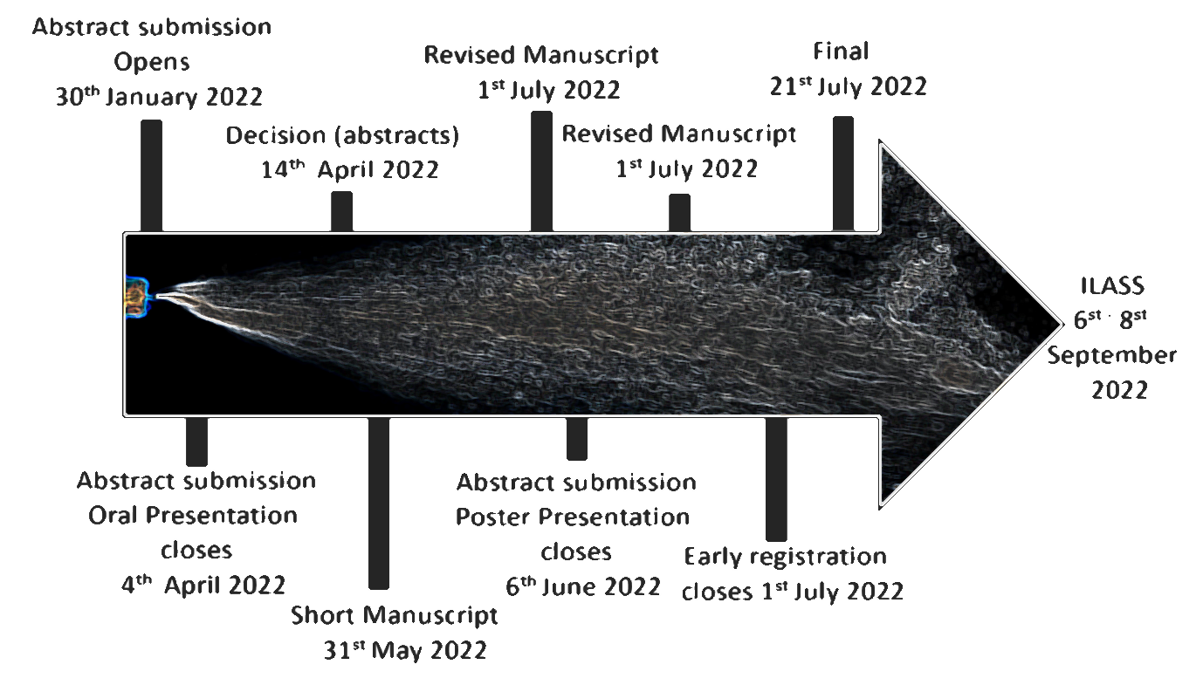
Figure 1. Example of a figure. Caption in Arial, centred, Figure and figure number bold. Spacing before caption is 6 pt.

The example in Figure 1 shows how to embed a figure into the text. You should use 1 blank line before and after the figure. The same applies to tables. Use the table example format provided below.

Table 1 - Example of a table. Caption in Arial, centred, Table and table number bold. Spacing after caption is 6 pt
 | Column 1 | Column 2
Row 1 | 5 | 34
Row 2 | 6 | 45
Row 3 | 7 | 46

Conclusions
For further details please refer to the https://ilass2022.net.technion.ac.il/, or to the organizing committee.

Acknowledgments
Acknowledgments
Acknowledgments

Nomenclature
a acceleration [m s⁻²]
F force [N]
m mass [kg]

References
References should be indicated in the text by full sized numbers enclosed within square brackets. Use different formats for journals [1], books [2], symposium proceedings [3] and web pages [4] as illustrated in the examples below. You may use “ASME” citation style in Endnote.
[1] Payri, R., Gimeno, J., Marti-Aldaravi, P., Vaquerizo, D., 2016, Atomization and Sprays, 26 (9), pp. 889-919.
[2] Wilcox, D. C., 1993, "Turbulence Modeling for CFD."
[3] Lampa, A., and Fritsching, U., Sep. 5.-7. 2011, 24th European Conference on Liquid Atomization and Spray Systems.
[4] Institute for liquid atomization and spray systems, http://ilasseurope.org/.

